Offline template proposal

Please note that all information mandatory for pre-registration are marked in bold. The template reflects the contents that have to be filled-in in the account of the coordinator.

Project Coordinator/partner information
- Contact details
- CV of coordinator/partner
CV shall be uploaded as pdf file max. 1 page, Arial 11pt, line spacing 1.15, max. 1 MB
- Tasks within the project
max 2,000 characters incl. spaces
- 5 references/publications
more can be provided as separate document in literature references
- Team members description and their relevant qualifications
max 2,000 characters incl. spaces
Project data
- Project title
- Acronym
- Expected project start date and end date
- Topic addressed
Keywords
- Supplementary keywords
Max. 5 keywords related to your project, separated by comma
Stakeholder Engagement
- Please describe which stakeholder(s) your planned project will be relevant for and how you intend to engage the stakeholder(s) during the application phase and/or during the lifetime of your project (if applicable to your project).
max. 2,000 characters incl. spaces
Project summary
- please provide your project summary. This summary might be used for communication and dissemination activities in case your project will be selected for funding. Please make sure that it is publishable.
max. 4,000 characters incl. spaces
Project description
Please provide your project description and use the following structure. The project description should:
a) provide the state of the art,
b) specify the expected project outputs/impacts and relevance to the call scope/topics,
c) provide information of the workflow and the linkage of work packages between the project partners.
The project should be in line with the requirements stated in the call text. The space is limited to 25,000 characters including spaces. Implementation of up to six graphics/images is allowed and possible (allowed formats are jpg, png or gif, max. resolution 600x600px, max. file size 2MB). No additional documents will be considered.
Max. 25,000 characters incl. spaces
Work plan
Here you can upload your work plan as a PDF document. The document must not exceed the length of 12 A4 pages (Arial 11pt, line pitch at least 1.15 - allowed file size: 5 MB, PDF file format, template available on submission website) Uploading of more than 12 pages is blocked by the online submission system.
The work plan should clearly describe the individual work packages, tasks, deliverables and milestones of the project. The work plan must also include a Gantt-Chart. Upload pdf file, max. 12 pages, Arial 11pt, line pitch 1.15, max. 5 MB
Data Management Plan
Please consider recommendations and checklist of questions provided in Annex D.
Upload pdf file, max. 1 page, Arial 11pt, line pitch 1.15, max. 1 MB
Communication and Dissemination Plan
Please consider recommendations and guiding information provided in Annex G.
Upload pdf file, max. 1 page, Arial 11pt, line pitch 1.15, max. 1 MB
Ethical Compliance
Proposals may be rejected from funding on ethical grounds if they do not comply with European and/or National/Regional Legislation
Please complete the ethical compliance in the proposal as requested by session 8.5
Financial Plan
Please insert the requested budget for all partners within the consortium into the appropriate columns within the submission platform. Also add your own contribution if applicable and write a short explanation for each budget item. Please be aware that only the coordinator can fill in the financial plan on behalf of the whole consortium.
Figure of the financial table as shown in submission system.
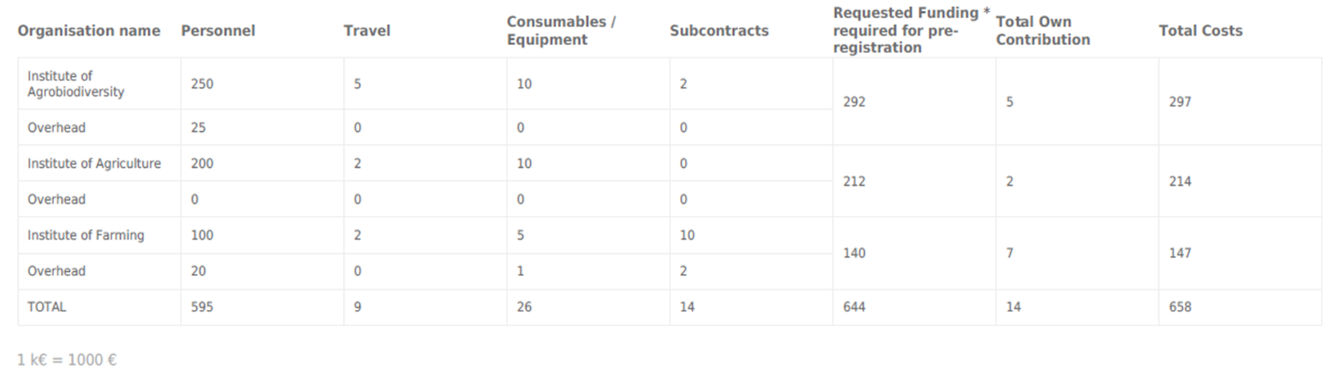
Evaluators (optional)
You may name a maximum of two experts who should not review your proposal because of conflict of interest.
Please enter the full name(s), affiliation (research institution, organisation) and reason for refusal of the expert(s).
max 2,000 characters incl. spaces
Letter of Commitment(s)
Partners who do not seek National/Regional funding from the Funding Parties listed in Table 1 (PPOE), may join the project at their own expense or with funding from another agency not contributing to the Call.
For each of these partners, you have to upload a Letter of Commitment via the Upload Field of the submission platform. If required, please use the template provided under Annex E and compile all Letters of Commitment into one pdf file.
Please do not upload any other letter types unless required by your national/regional regulations. Additional uploaded documents will not be considered.
Upload one pdf file
Additional literature References (optional)
Upload pdf file, max. 2 pages, max. 1 MB
Figures (optional)
You can upload up to 6 figures. Please make sure to use the correct format (jpg, png or gif) and maximum size that is supported by the online submission system (max. 2MB and 600px x 600px). A detailed instruction on how to upload and implement figures within the text fields is provided in the submission system menu FIGURES. Please check well in advance of the deadline that your figure is accepted by the submission platform.
Upload up to 6 images (2 MB, 600px x 600px) as jpg, png or gif

